PROJECT AND TEAM INFORMATION
Project Title
Point of Sale System
Student / Team Information
Team  Name: | FS-VI-T002
Team member 1 (Team Lead) | Michael Ally Mulungu: 2023452 Vabronoble1@gmail.com  
Team member 2 | Reward Kundai Magama: 2024190 Kundaimagam a05@gm ail.com  
Team member 3 | Aryan Khatri:2023759  arykha0123@gmail.com  
Page 1





PROPOSAL DESCRIPTION
Motivation
Retail businesses require fast and efficient POS system. A poorly designed interface can slow down transactions, confuse users, and reduce productivity. By applying proper layout styling techniques, the system can become more usable, visually clear, and professional. This project also helps in understanding frontend structure and practical UI design for real-world applications.
State of the Art / Current solution
Many POS systems use web-based interfaces with dashboard-style layouts and responsive design. They rely on CSS frameworks like bootstrap to create structured and a good interface. Modern POS systems emphasize minimalist design, clear buttons and icons, well-organized sections such as Products, Cart, and Payment, and fast search functionality. However, beginner-level layouts often lack proper spacing, consistent styling, human-readable variable names, and structured layout planning. This project aims to improve these aspects by creating a cleaner and more organized POS interface.
Project Goals and Milestones
The main goal is to build PoS(Point of Sale )system which cleaner and more organized
•  •  •  •  •  • | Step 1: Design a structured POS layout.  Step 2: Improve spacing, alignment and overall styling.  Step 3:Make the layout responsive for different screen sizes.  Step 4:Enhance UI components with clean and modern design. Step 5: Add advanced features to the Point Of Sale.  Step 6: Test the system by simulating crashes and checking recovery.

Project Approach
We will build the system step by step, starting with the design and moving into implementation and testing.
• Create Semantic HTML Structure: Design the basic layout using semantic HTML tags.
• Apply CSS Styling: Apply a consistent and professional color scheme .
• Implement JavaScript Functionality:Add dynamic cart management and add interactive elements
such as modals and alerts.
• Integrate Database: Create a simple interface so users can easily upload, retrieve, and delete files.
• Optimize Layout: Ensure proper alignment of all sections
Page 2



System Architecture (High Level Diagram)
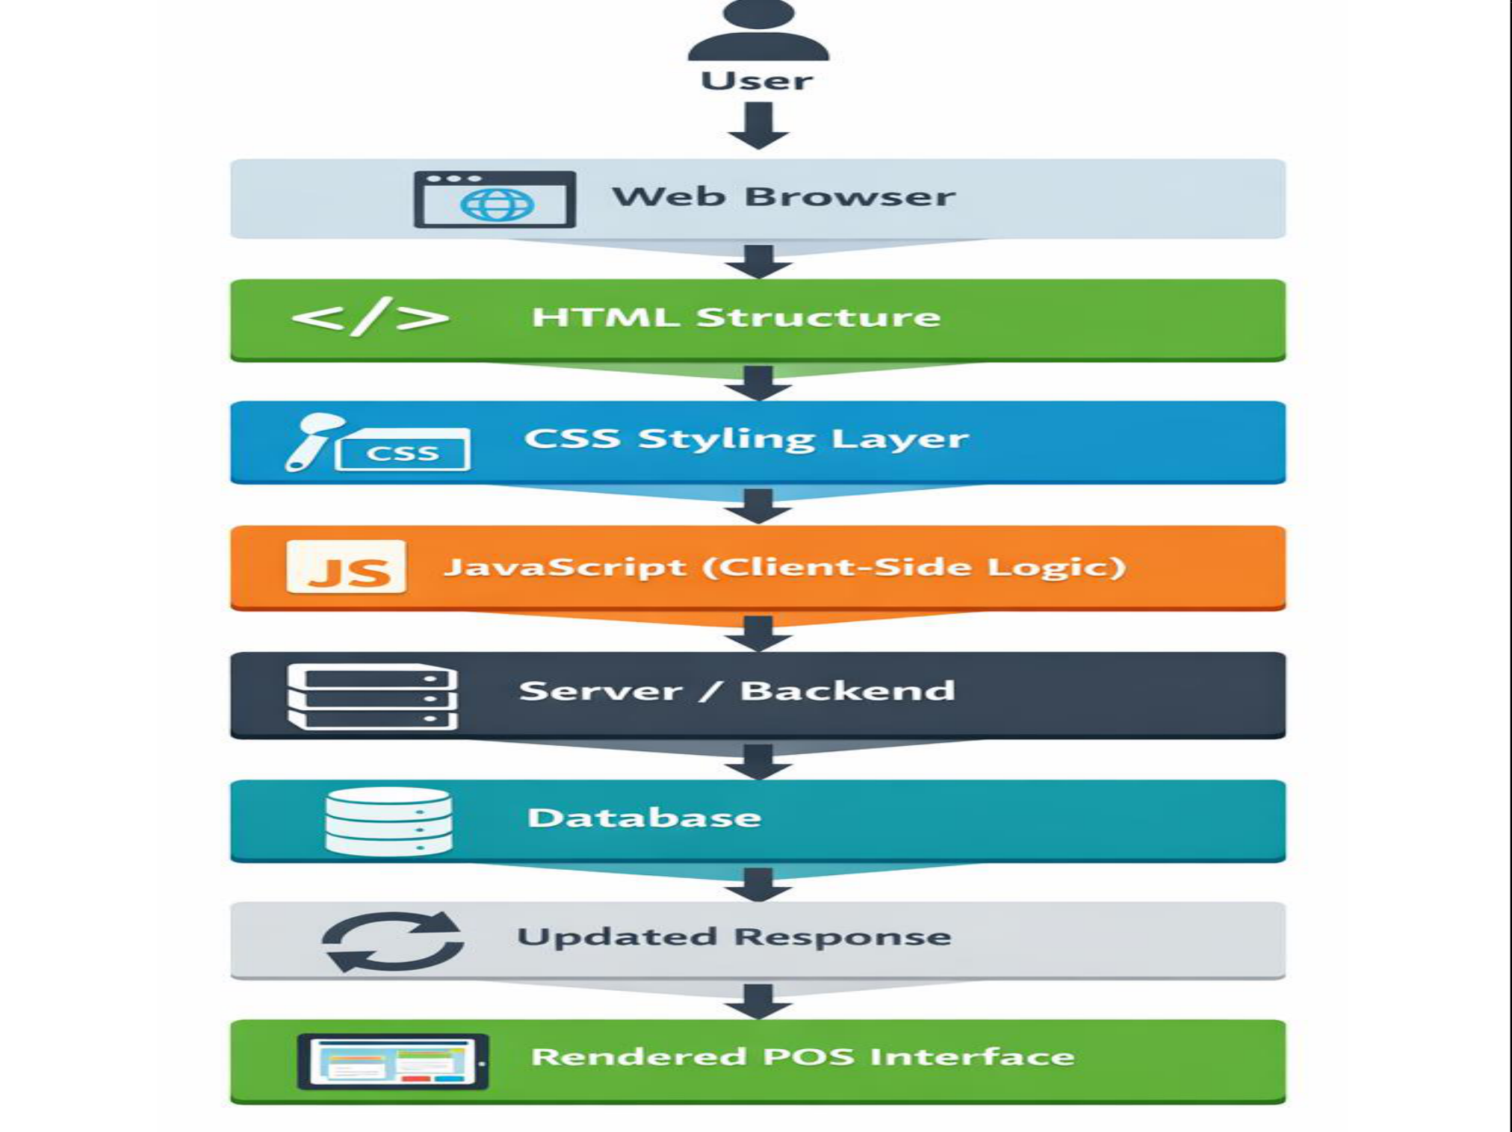
Project Outcome / Deliverables
By the end of the project, we will deliver:
•  •  • | Fully structured PoS layout.  Clean and responsive design.  Organized product and cart section.

Assumptions
• The system is a web-based.
• User accesses it through modern browsers.
• The focus is layout and styling and adding advanced features.

References
Hickson, I. and Hyatt, D., 2011. Html5. W3C working draft WD-Html5-20110525, 53.
Elrom, E., 2016. CSS, Bootstrap, & Responsive Design. In Pro MEAN Stack Development (pp. 131-164). Berkeley,
CA: Apress.
Susanto, J. and Fenriana, I., 2024. Web-Based POS with Apriori Market Basket Analysis. bit-Tech, 6(3), pp.271-280.
Ramadhani, I., Nindyasari, R. and Murti, A.C., 2025. Design and Development of a Web-Based Point of Sale
System for Small-Scale Retail Management. bit-Tech, 8(1), pp.181-189.

Cheng, D., 2024, July. Research on HTML5 Responsive Web Front-end Development Based on Bootstrap Framework. In 2024 7th International Conference on Computer Information Science and Application Technology (CISAT) (pp. 711-718). IEEE.
Page 3

